Continuous Integration and Continuous Deployment Lab

Experiment – 9

**Name : Harivansh Mathur**

**Roll No : R171218043**

**Uploading Artifacts using Nexus Server using Command Line**

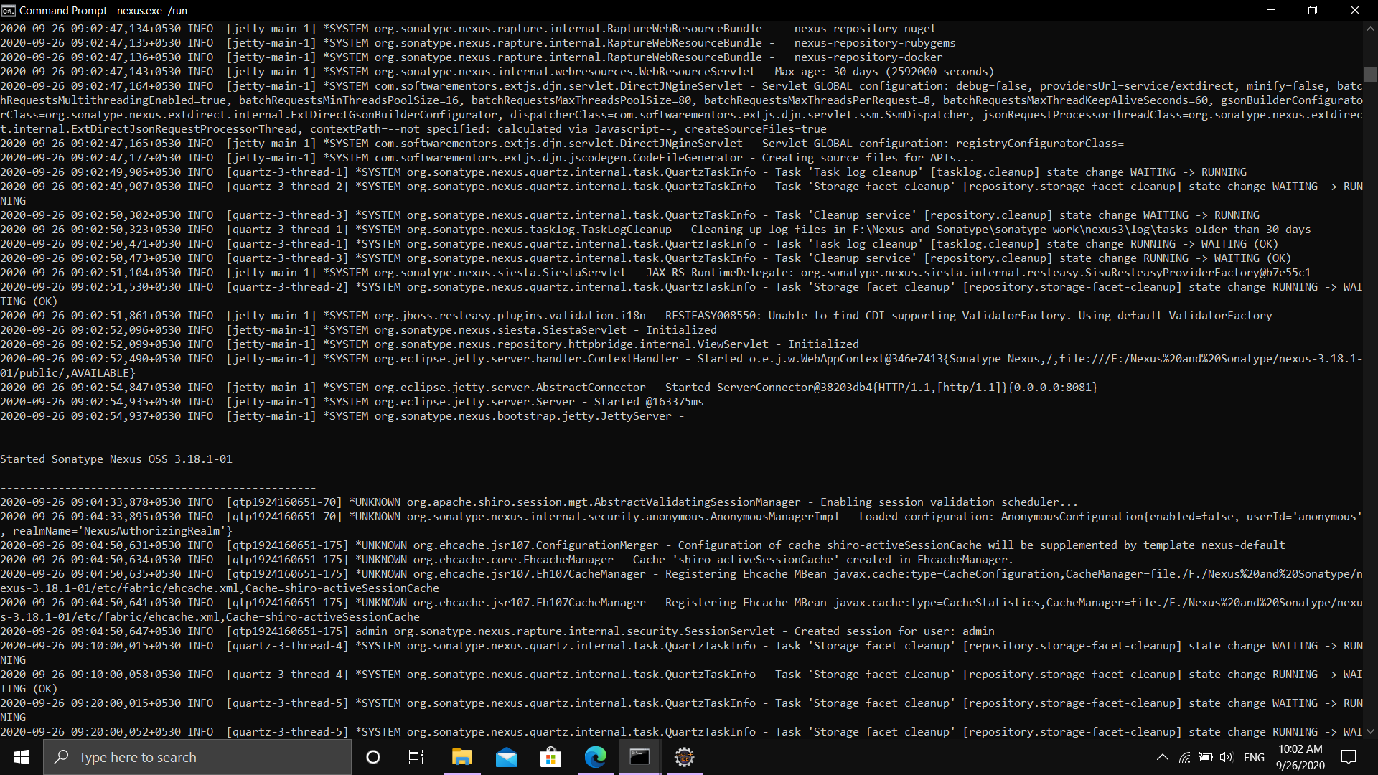

Starting Sonatype Nexus on localhost

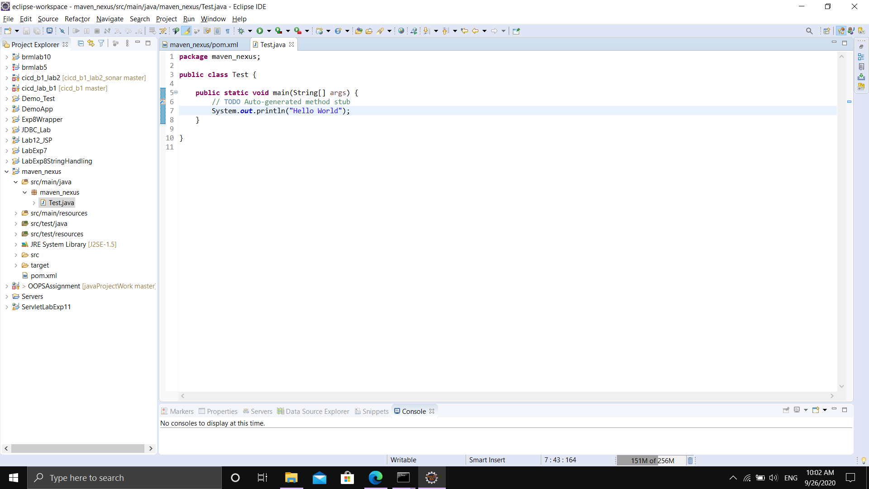

Simple Java Program in a Maven Project

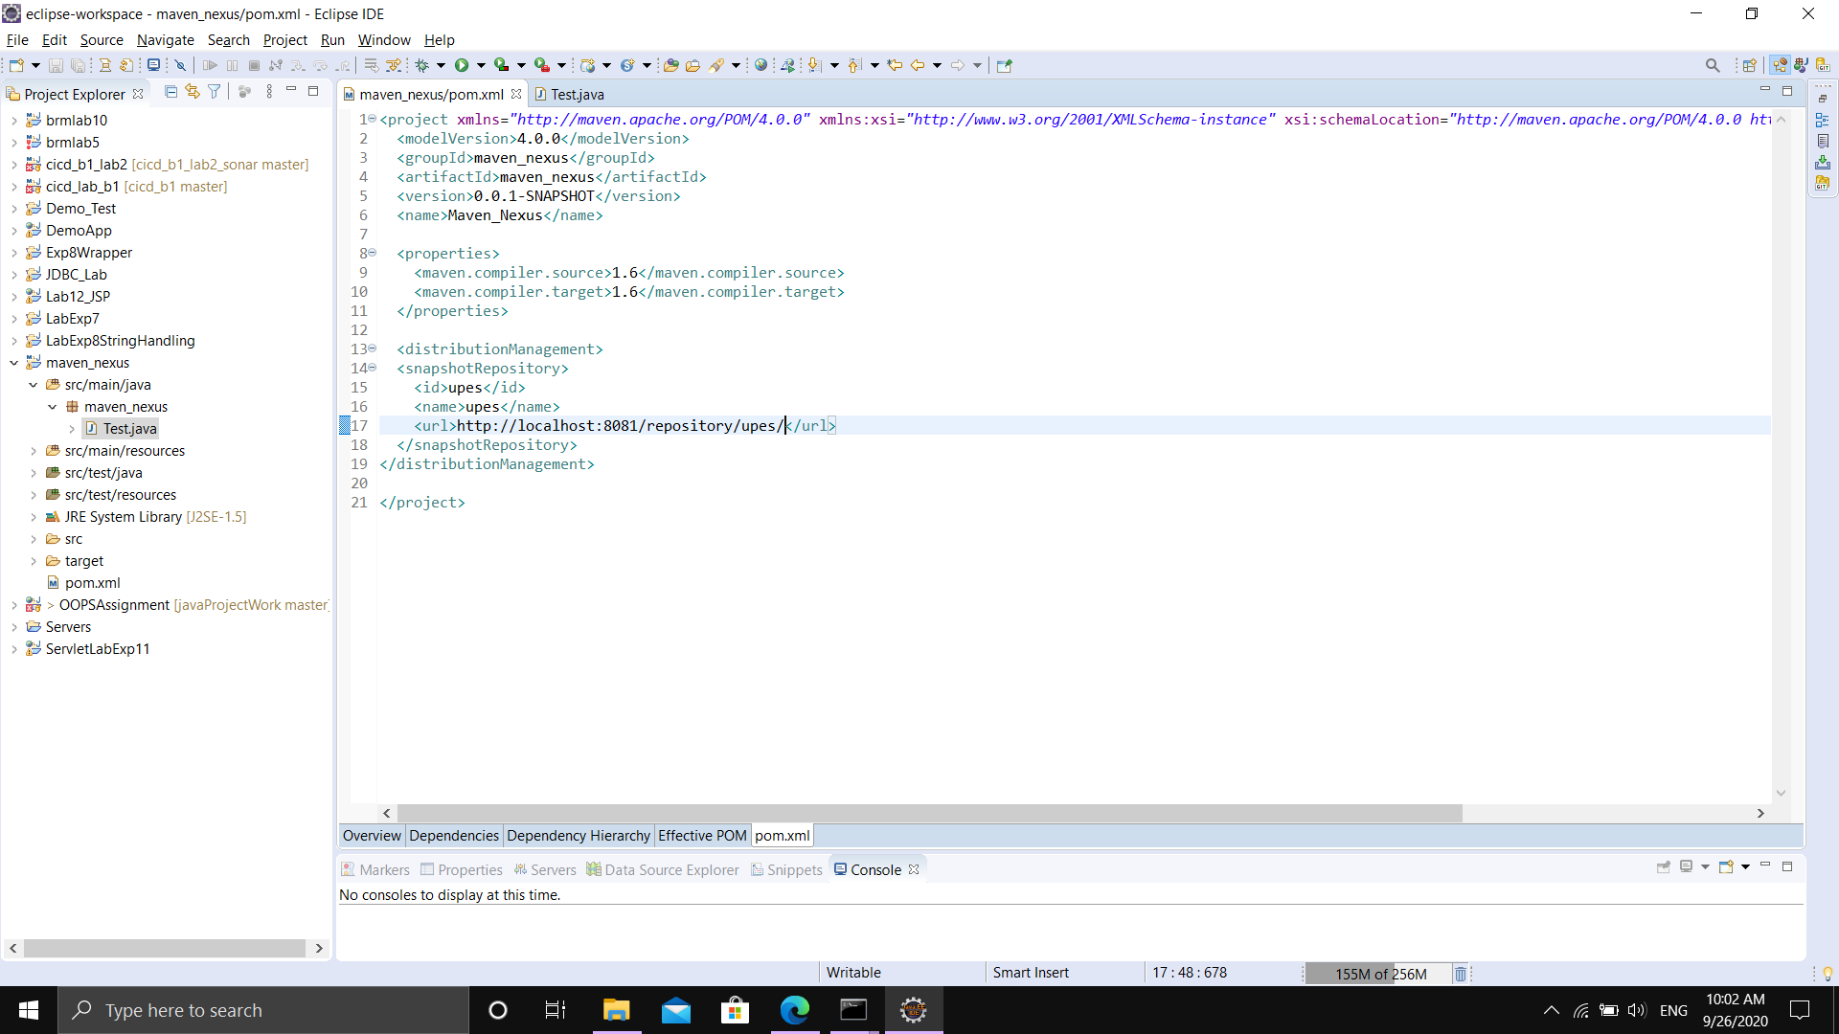

POM.xml of this maven project

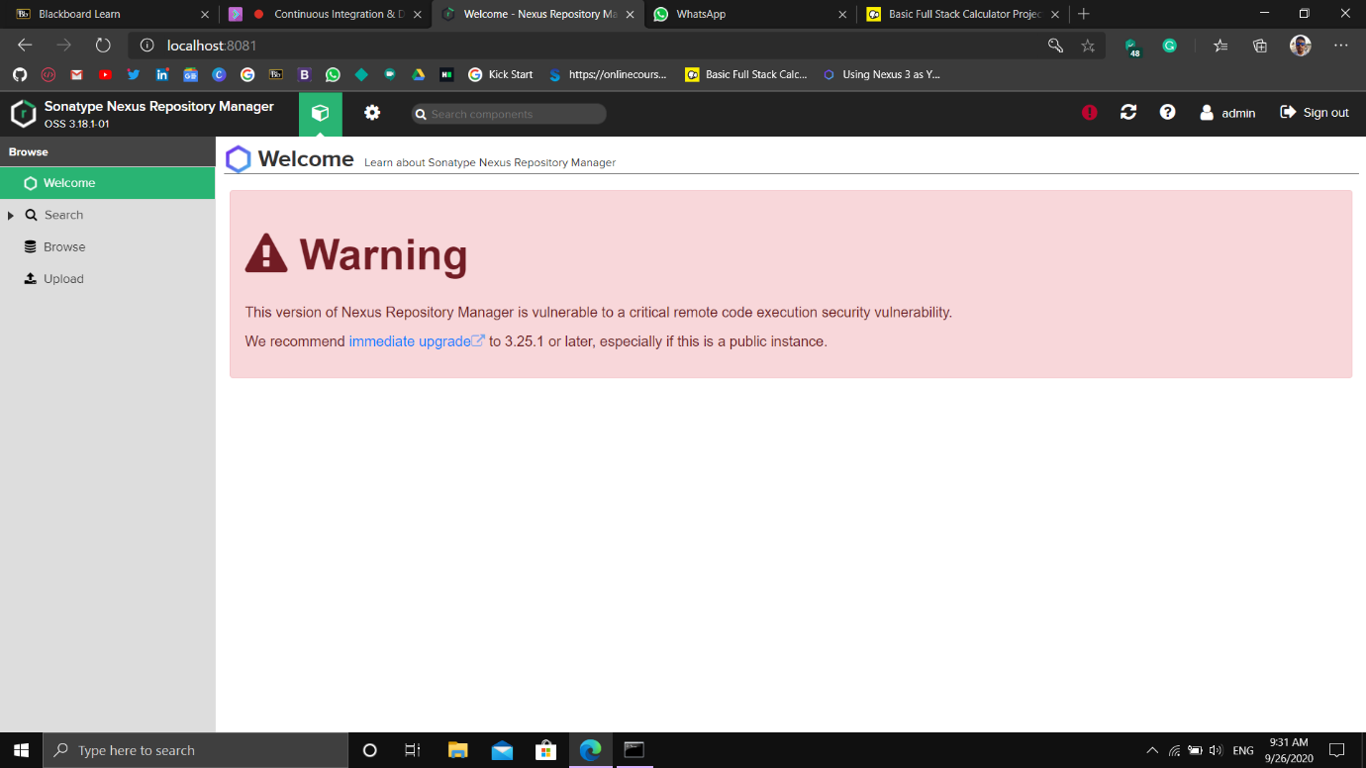

Nexus Dashboard

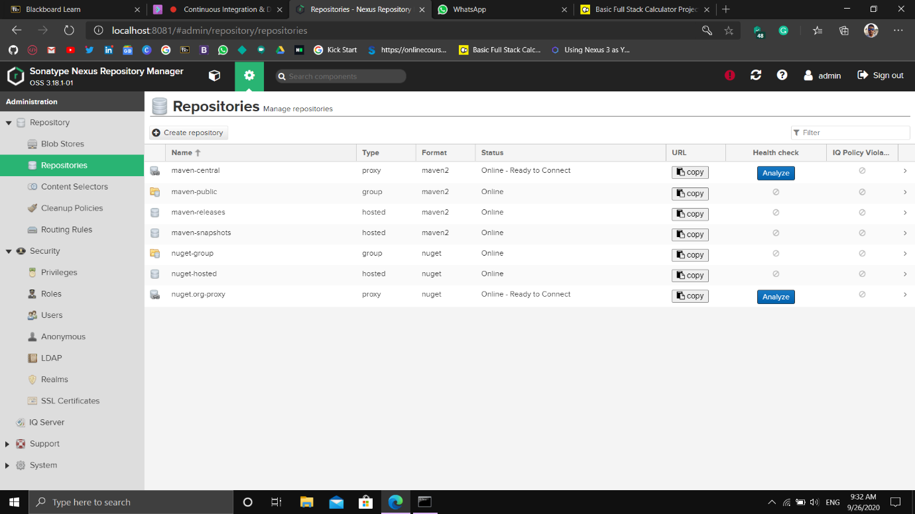

Repositories which store artifacts for projects

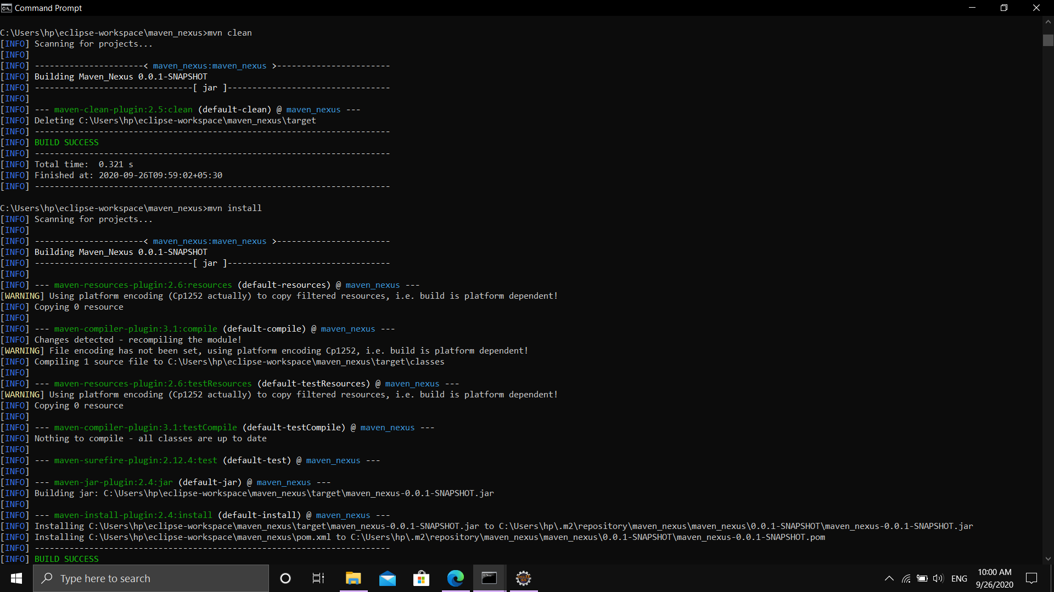

Clean and install command in maven

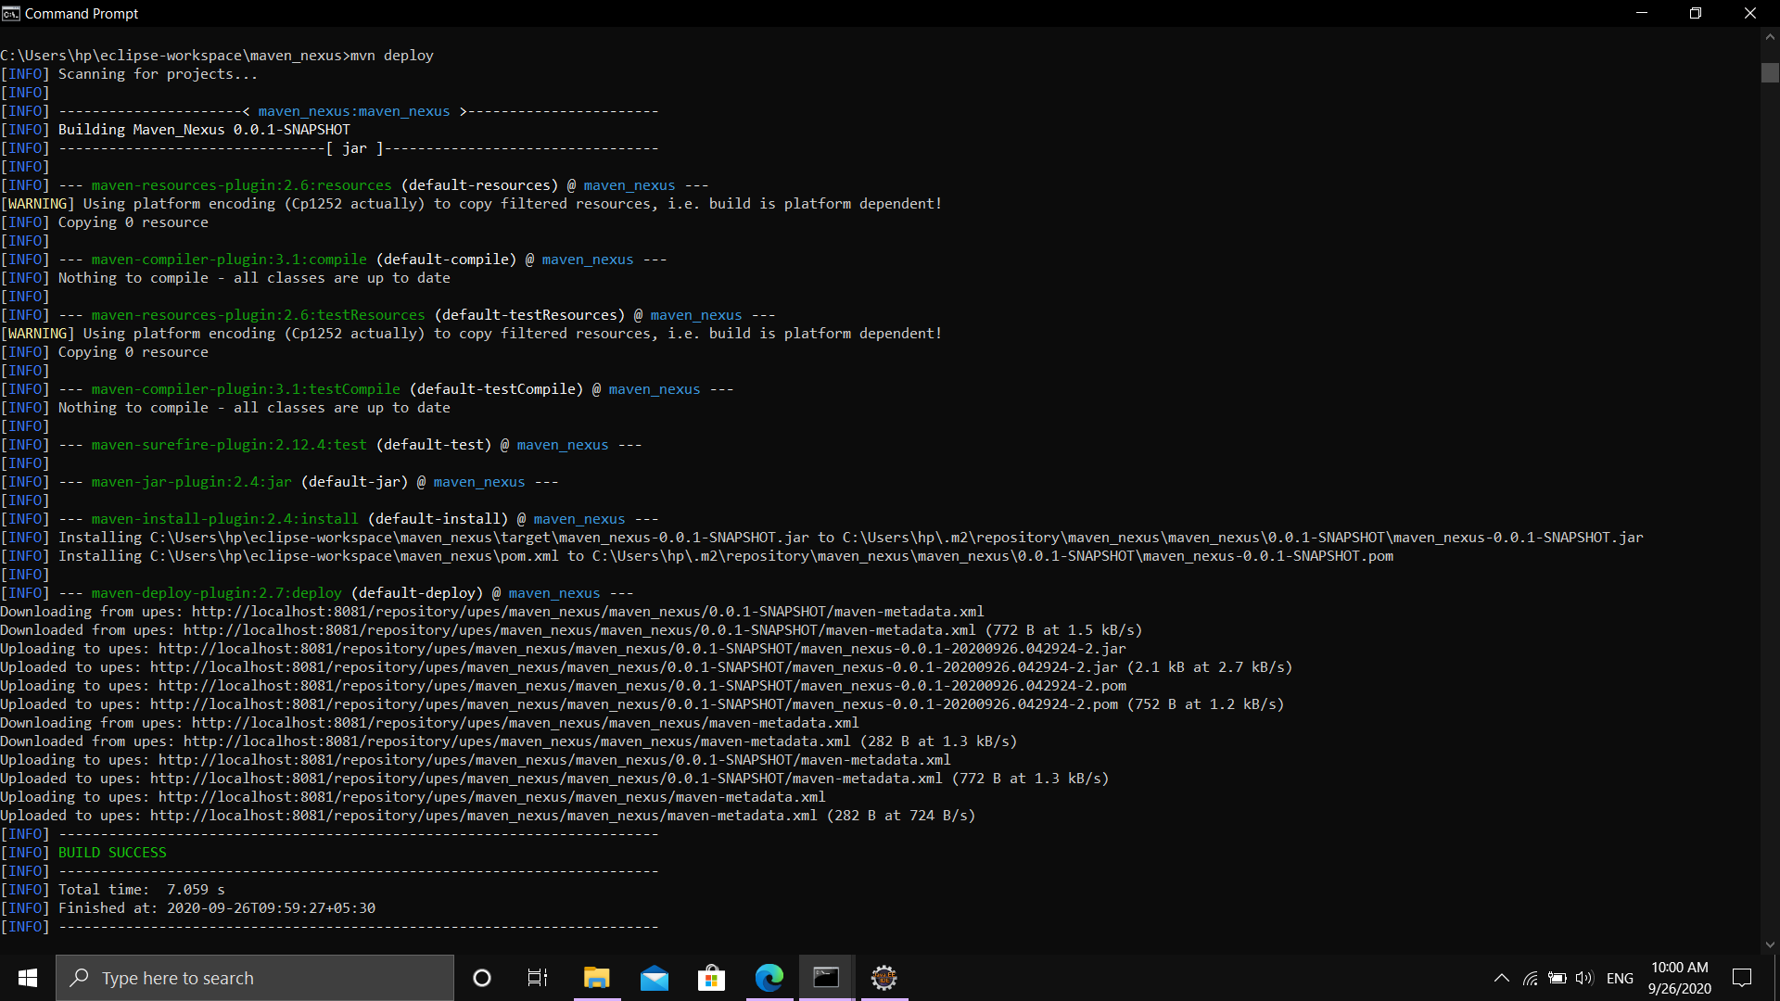

Deploying artifacts to nexus server using maven command mvn deploy from command line

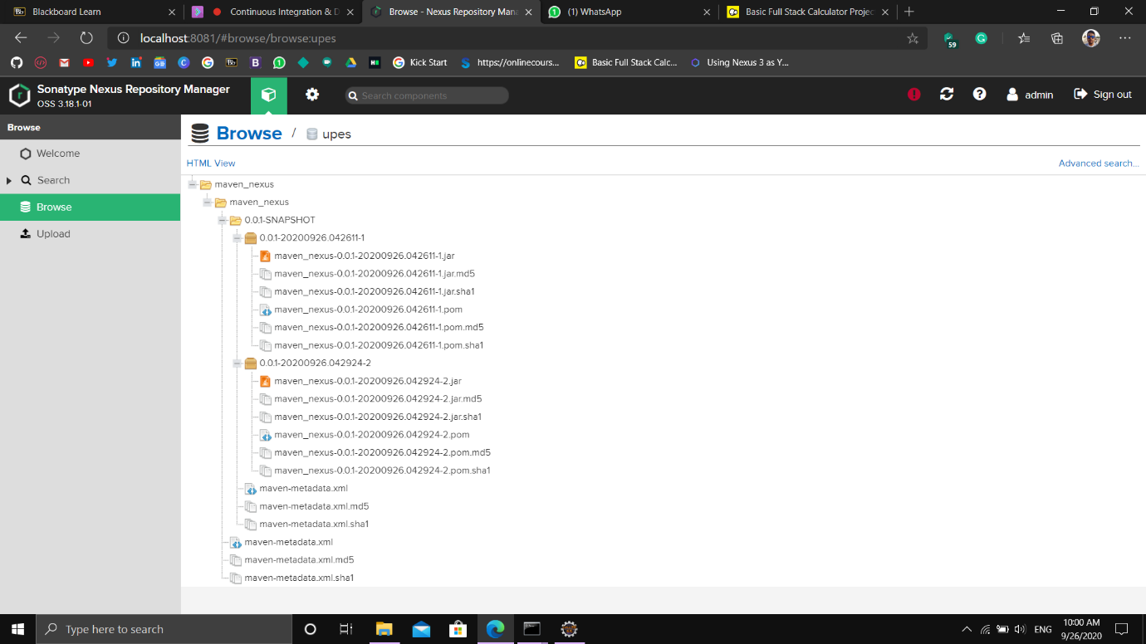

Jar file showing in nexus after deploying